TCSS 465A

Embedded Real-Time System Programming

Midterm - Spring 2006

1) CLEARLY show on a timing diagram the parameters for a real time periodic task:
- Compute time C_{i}
- Finish time f _{i}
- Arrival time a _{i}
- Phase Φ _{i}
- Start time s _{i}

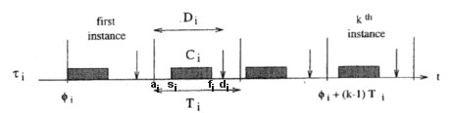

And define:

- Response time:

R _{i} = f _{i} - a _{i}

- Lateness:

L _{i} = f _{i} - d _{i}

- Laxity:

R _{i} = d _{i} - a _{i} - C _{i}

- Name five properties that real-time systems must have to support critical applications:

1. Timeliness – must meet deadlines appropriately

2. Design for peak-load – Can’t crash under peak loads

3. Predictability – Must not have unanticipated surprises

4. Fault Tolerance – The system must be robust and fail-safe

5. Maintainability – Must be modifiable as requirements evolve

- Define and distinguish between each of the following scheduling algorithms:

  - Earliest Due Date
1 | sync | L_{max} : Independent, sync, aperiodic, non-preemptive tasks. Minimize L_{max}
Tasks are scheduled in order of non-decreasing deadlines. Provides optimal schedule

  - Earliest Deadline First
1 | preem | L_{max} : Independent, preemptive, dynamic tasks. Minimize L_{max}
Task with earliest deadline has priority. Provides optimal schedule.

  - Latest Deadline First
1 | sync, prec | L_{max} : Precedence, sync, aperiodic, non-preemptive tasks. Minimize L_{max}
Schedule backwards with latest deadline task scheduled “first”. Provides optimal schedule.

- Apply EDF to schedule the following set of tasks J_{i} with precedence constraints:

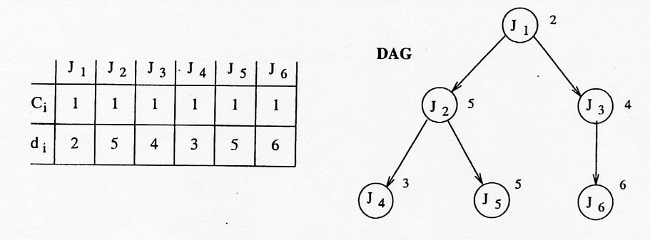

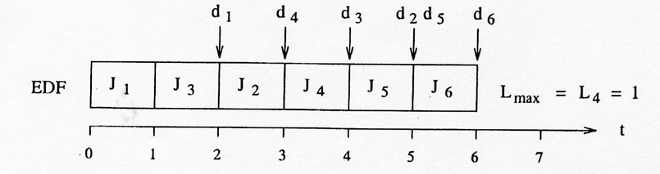

Apply LDF to schedule the set of tasks:

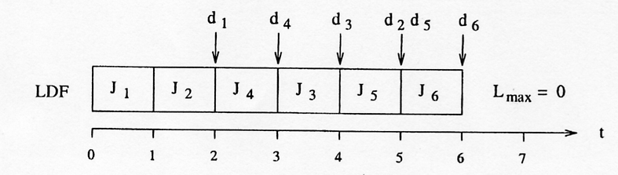

5) Verify the schedulability according to the Rate Monotonic algorithm for the following set of periodic tasks.
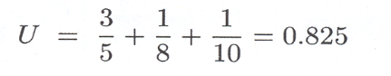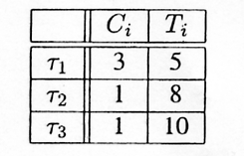
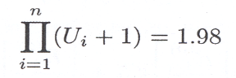

Construct the schedule using RM.
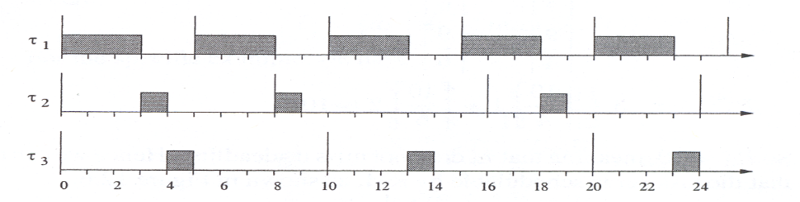
- You did two projects using the NetBurner A/D converter. In the first you used Port A as a 4 bit output port. What did you need to do to program it?

Initialize: The default on the Configuration and Control registers are for digital I/O on Port A,
so nothing was required. The Port A Data Direction Register bits needed to be
programmed for output.
Output: The output follows writes to the buffered Data Register in the A/D.

On the second project you used both Port A and Port B as A/D input Ports. What did you need to do to program it in that mode?

Initialize: The Configuration Register needs to be set to “stop”, Port A & B Control Registers set,
Port A & B Data Direction Registers set, Port A & B QADC timing registers set, and
the Configuration Register set to “start”. The Queue must be programmed for the
sampling sequence, and finally, the scan initiated.
Input: The input is obtained by reading from the queue.

- On the third project, what did your thermistor characteristic look like (resistance vs temperature) ?

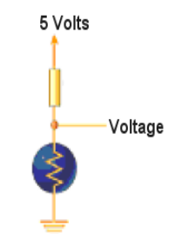

What should the voltage vs temperature curve look like in the circuit?

See graph above.

